COMMUNICATION EFFECTIVENESS OF SURABAYA CITY GOVERNMENT THROUGH TWITTER AND FACEBOOK
Saodatul Qhamariyah¹, Achmad Nurmandi²
Saodatulqhamariyah18@gmail.com
Magister of Government Affairs and Administration, Universitas Muhammadiyah Yogyakarta

ABSTRACT
Advances in information and communication technology encourage the government as a stakeholder to have social media accounts. Likewise, the community is also required to have social media as a means of communication. The importance of social media has a very significant impact, especially in the field of government, for example as a medium in conveying suggestions and complaints from the public to the government or vice versa. Twitter and Facebook are some of the social media that are very popular with Indonesians. Including the Surabaya City Government, to support and develop policy programs made, they use this social media tool as an effective medium of communication. The purpose of this study was to determine the level of effectiveness of Surabaya city government communication via twitter and facebook. The research method used is descriptive qualitative by utilizing the Nvivo application to process the data. In this study, there are several assessment indicators used as benchmarks, namely (1) Accuracy, (2) Creativity, (3) Activeness, (4) Interaction, (5) Transparency. From the research results, it is known that the effectiveness of communication via Twitter is better than Facebook in terms of accurate information, creativity, activeness, and transparency. Meanwhile, in terms of interaction, Facebook is higher. Therefore, the Government is required to be even more innovative in conveying information to the public, so that people have an interest in knowing information about government and policies that have been announced.
Keywords: Communication Effectiveness, Facebook, Twitter

- INTRODUCTION
The development of the times is increasingly rapid, giving rise to many new inventions, one of which is technology. The development of technology cannot be separated from the growing needs of humans on earth. Technology makes it easy for humans to complete their work, including communicating. With the existence of social media, a person can communicate openly, effectively and efficiently to convey information to other people, with various backgrounds and interests (Farid & Ari, 2021). Currently, Indonesians both in urban and rural areas are already using social media. Social media used by Indonesians such as Facebook, Instagram, Twitter, Path, Youtobe, Blackberry Messenger, Line and Whatsapp. In addition, there are also social media in the form of blogs and online media, which are managed personally or by a corporate institution (Siagian, 2015).
Based on data from http://statista.com, the most widely used social media by Indonesians based on age groups, Facebook is still in the highest position, then Twitter is in the third rank (Novalinda Viani & Budi Santoso, 2017). According to the news delivered by Kominfo of the Republic of Indonesia, there are currently 63 million internet users in Indonesia. And the social media most accessed by Indonesians are Facebook and Twitter. Indonesia is the fourth highest Facebook user after USA, Brazil and India. And occupies the fifth highest position of Twitter users after USA, Brazil, Japan and England.
The existence of social media in Indonesia is used for various purposes, both in politics and in the field of marketing. In the political field, for example, it is used as a medium for political campaigns, or as a medium of communication between the government and society in running the wheels of government (Islamiyah & Rachman, 2018). Communication between the government and the community is very important to create participation from the community or as a medium for community control of the government (Munandar & Suherman, 2016).
In social media there is no longer one man one vote, but one person can have the power equal to tens, hundreds, or thousands more people. This is the advantage of social media: it is effective as a means of exchanging ideas. The spread of various ideas, including the content of the campaign via social media, is very fast and almost limitless. On Twitter, for example, just by tweeting, information is spread widely to all followers, and so on by means of work such as multi-level marketing (Nur, 2018).
The city of Surabaya is one of the cities that has implemented the Smart City concept, the city of Surabaya has been named a city that is included as a Smart City because of its innovation in reducing the level of congestion in the city with the concept of Traffic Light. In realizing all of this, of course, the role of social media is very influential in the implementation of government in the city. Therefore, the authors in this study will examine the extent to which the effectiveness of Surabaya city government communication. The social media that we will measure are Facebook and Twitter. Because these two media are the media most widely used by the Indonesian people. The purpose of this study is to compare the effectiveness of Surabaya City Government communication via Facebook and Twitter.
- LITERATURE REVIEW
- Mass communication
Mass communication is the process by which media organizations create and disseminate messages to large audiences. These organizations will disseminate messages that will influence and reflect the culture of a society, and then they will present this information simultaneously to a wide and diverse audience. This makes the mass media part of one of the strongest institutions in society. In mass communication, magazines, or featuring compelling news terraces for a news story. it is a science in the sense that it includes certain principles about how communication takes place which can be confirmed and used to make things better (Syarief, 2017).
Mass communication has its own characteristics. Elizabeth Noelle Neuman (in Rakhmat, 1983: 92) mentions four main signs in mass communication, namely:
  - Mass communication is indirect
  - Communication is one-way
  - Communication is open
  - Has a geographically dispersed public
Rodman in his book mass media in a changing states that the difference between mass communication and other types of communication is that the feedback process is slow and the interaction between the communicator and the communicant is limited. Mass communication, like any other applied science, has its own characteristics. There are also characteristics of mass communication are:
a. Institutionalized communicators
The first characteristic of communication is the communicator. According to Wright, the communicator is engaged in a complex organization. Chronologically the process of composing messages by the communicator until the message is received by the communicant
- General messages Mass communication is open, meaning that mass communication is intended for all people and is not aimed at a particular group. Therefore, mass communication messages are general, mass communication messages can be facts, events or opinions.
- Communicants are anonymous and heterogeneous. In mass communication, the communicator does not recognize the communicant (anonymous), because the communication uses the media and is not face to face. Besides being anonymous, mass communication communicants are heterogeneous, because they come from different layers of society and can be grouped based on factors of age, gender, education, occupation, cultural background, religion and economic level.
- Simultaneous messages The advantages of mass communication compared to other communications are that it achieves relatively large numbers of suggestions by audiences or communicants and is not limited. Even more than that, the many communicants simultaneously received the same message.
- Prioritizing content over relationships Every communication involves an element of content and an element of relationship at the same time. In interpersonal communication, the element of relationship is very important, whereas in mass communication, what is important is the content
- One-way in nature In short, mass communication is communication using or through mass media. Because through the mass media, communicators and communicants cannot make direct contact.
- Limited stimulation of the senses In mass communication, stimulation of the senses depends on the type of mass media.
- Delayed feedback (delayed) Feedback or feedback is an important factor in any form of communication. The effectiveness of communication can often be seen from the feedback given by the communicant.

- The Effectiveness of Communication through Social Media
Social media is a media platform that focuses on the existence of users that facilitates them in activities and collaborations. Therefore, social media can be seen as an online medium (facilitator) that strengthens the relationship between users as well as a social bond. In its application, social media is chosen by the government for reasons
- The re-actualization process occurs because of the awareness to keep up with technological developments and reduce publication through the mainstream media for budget savings;
- The social media channel is chosen so that it can be more effective in conveying information widely and quickly to the public, especially on Facebook, Instagram and Twitter accounts;
- There are several relevant social media use strategies that have resulted in a positive response from the public. In addition, the role of the media is also very influential in the field of bureaucracy because it is able to shorten and simplify the flow of government bureaucracy which has been usually slow and convoluted so that the flow of communication runs without any more barriers and barriers which sometimes make it difficult for the public to be heard more by leaders and governments about aspirations and needs.
Effective Communication is communication that has succeeded in achieving goals with feedback (response) that is in accordance with the goals of the individual communicating. This is what is called a successful (successful) communication condition. Communication will be successful (there is a similarity in meaning) if the message conveyed by the communicator matches the frame of reference, namely the experience guide and understanding obtained by the communicant. Field is also an important factor in communication. If the communicator's field of experience is the same as the communicant's field of experience, communication will run smoothly. Conversely, if the communicant's field of experience is not the same as the communicator's field of experience, it will be difficult to understand each other (Muna & Huberman, n.d.).
The development of information and communication technology is certainly a bridge between the government and the community in interacting either individually or in groups. Social media users are not bound by social, economic and political status, social media and mainstream mass media have different characters in spreading messages to audiences and social media is a supporter of political communication networks in a democratic state (Susanto, 2017). Social media presents different alternative ways of communicating, including as a political instrument, both to form public opinion, as well as a medium for interaction between parties and politicians and their constituents. In the context of elections, social media occupies a strategic position as one of the campaign media (Hasan, 2016). In terms of public opinion, for example, the influence of text will cause various public opinions so that management must pay attention to social media instruments in the creation of texts or sentences conveyed by the government (Syarif, 2017).
The effectiveness of communication is also very important through social media, the substance of political messages is faster and easier for the audience to digest, because at any time the audience can access information without barriers and geographic boundaries. Social media is also very effectively used as a medium of communication, especially in providing information and receiving feedback from audiences. Feedback from audiences can bring closer and closer relationships between political communicators and society. Moreover, nowadays, the use of social media in the community is increasingly popular and growing, even in remote villages. So that with good information packaging, the public will easily understand the political messages conveyed by political communicators. In the end, through the delivery of political messages that are appropriate and carried out effectively, it will be able to attract public sympathy so that they will receive the intentions desired by political communicators (Siagian, 2015). The effect of effectiveness will affect community participation in the implementation of programs that have been made by the local government (Novalinda Viani & Budi Santoso, 2017). In addition, the role of social media used by the government will slightly minimize hoax news created by fake accounts (Anggriawan & Mahanani, 2018).
The social media used by the government will make it easier for the public to convey their aspirations, complaints or suggestions that can be conveyed directly. This of course strongly supports the principles of good governance governance (Suciska, t.t.). In the context of political communication, there are four functions that are in line with the function of the press, namely
(1) The function of broadcasting information, namely providing information to the public about various things including events, ideas, etc.,
(2) The function of educating or educating, namely containing various contents contains knowledge so that it can advance society,
(3) The function of influencing, namely influencing in the form of community persuasion with the aim of attracting and influencing attitudes and behavior as expected, and
(4) entertaining function, namely being a means of community entertainment (Wahyuningtyas, 2017).
The phenomenon of the presence of social media as a result of the development of information and communication technology is extraordinary. With a variety of services that can be used, social media has changed the way we communicate in society. The presence of social media even impacts the way we communicate in all areas, such as marketing communications, political communications and communication in learning systems. It is very interesting to study whether the presence of social media only impacts changes as conventional communication tools become modern and fully digital, or also causes communication to be more effective (Setiadi, t.t.). Social media has an influence in shaping social networking to help and support people in several countries who are still in the process of transitioning to democratic societies (Rasasti, 2017).
Current government communication can be done directly through social media such as Facebook, Instagram or Twitter. Twitter content can form a person's personal branding. The formation of personal branding can be done through writing in his twitter. The formation of personal branding can be seen from the theme of writing, retweet and favorite numbers, type of writing, writing uniqueness, and purpose of writing. The formation of personal branding is needed by someone not only through writings conveyed through the media, but also the need for real action participation and involvement in community life (Widiastuti, 2017). Government organizations have published programs using a social media approach, one of which is twitter. The presence of Twitter has gone beyond its original function as a medium for self-expression, as a media for publication and communication for government organizations to the public (Wahyuningtyas, 2017).
The use of social media such as Facebook, Twitter and Instagram is a favorite media for stakeholders in politics, learning or marketing. Based on posts by Facebook owner Mark Zuckerberg on his Facebook account. He said that the number of Facebook users has reached 2 billion users worldwide, while Twitter users have reached 328 million worldwide (Fadilah, 2016). With the increasing number of social media users, political actors must be able to take advantage of social media so that they can get support or positive feedback from the community because when they fail to take advantage of social media it will have an impact on the image they have. Therefore, there is a need for effective communication. To increase the effectiveness of communication, there are several strategies used as benchmarks in calculating the extent to which the level of effectiveness has been achieved, namely (1) accurate (2) activeness (3) transparency (4) creativity (5) interaction (Setiadi, t.t.)
Source: Journal of the use of social media for communication effectiveness
Efektivitas Komunikasi
From the theoretical framework above is a general description of this research. Which in this study will compare the effectiveness of social media communication in the form of Twitter and Facebook of the Surabaya City Government. The level of communication effectiveness is assessed from five aspects which include:
- Accurate
In terms of data accuracy, the delivery is clear and easy for all groups to understand. Also, what was conveyed was in accordance with what was happening in reality.
- Creativity
In terms of creativity, seen from the content conveyed by the 2 media, both from the way to attract public attention by giving quizzes, or challenges in the media.
- Activeness
In terms of activeness, it can be seen to what extent the twitter and facebook accounts of each government have been uplouded every day or every week. Active in delivering news or activities carried out.
- Transparency
In terms of transparency, it is assessed from the aspect of delivering information to the public and easy access to this information by the public. So that in this way the community is able to control the performance of the government and also the policies that have been made.
- Interaction
This aspect is assessed by how the government responds in providing responses to the public which are conveyed through two media, Twitter or Facebook. This can also be seen from the comments column of the posts of each media.

- METHOD

The research method used in this study uses descriptive qualitative methods to see the effectiveness of Surabaya City Government communication through social media Facebook and Twitter. These two media contents were analyzed using the NVIVO PLUS application by collecting data from Twitter and Facebook from the Surabaya City Government. The data is retrieved through the Ncapture application, which is already connected to NVIVO, making it easier for researchers to retrieve data. Then the data that has been generated from government social media is processed through the crosstab and cluster analysis features.

Table 1 Surabaya City Government Twitter Account
Institution | Account Name | Followers | Following | Number of Tweets | Joined since
Pemkot Surabaya | @BanggaSurabaya | 80,6 rb | 95 | 6.836 | April 2015
Source: Surabaya City Government Twitter Account

Table 2 Facebook Accounts of the Surabaya City Government
Institution | Account Name | Followers | Like
Pemkot Surabaya | Bangga Surabaya | 118 rb | 111 rb
Source: Surabaya City Government Facebook Account

- EXPLANATION
The city of Surabaya is the city with the second highest population after Jakarta. Therefore, the Surabaya City Government has launched various programs based on information technology and technology to develop and improve services to the people of Surabaya City. One of them is the use of social media. According to one of the news reports, Radar Surabaya said that 78% of the people of Surabaya city access the internet for social media. This social media is one of the media used by the Surabaya City Media Center which aims to accommodate aspirations and complaints or criticism and suggestions from the public. Below is a diagram of the post on Twitter by the Surabaya City Government. The current Twitter account for the Surabaya City Government is @BanggaSurabaya, which has been joining since 2015 in April. Previously the name of the Surabaya city government twitter account was @PemkotSurabaya

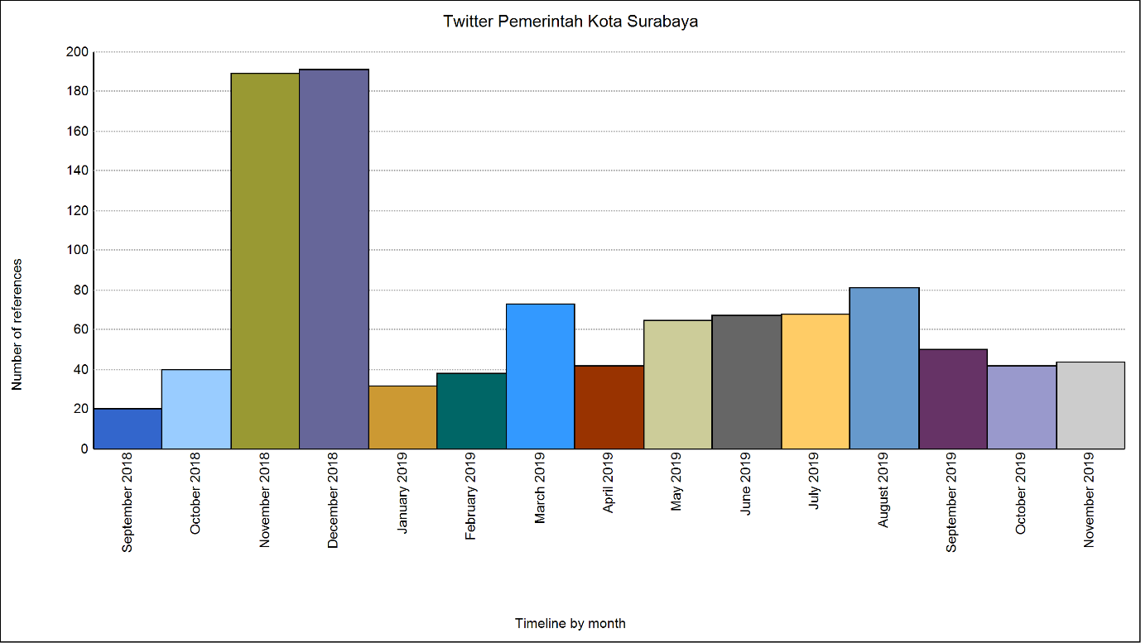
Source: nvivo12 plus
Figure 1. Surabaya City Government Twitter from 2018-2019

Effectiveness of Surabaya City Government Communication via Twitter and Facebook
Twitter is one of the social media used by the Surabaya City Government in increasing effective communication to support various program activities that have been planned or have been implemented as a form of information that can be accessed by all people. Based on the theory used to measure the effectiveness of Surabaya City Government communication, it can be seen in the following diagrams and tables:

Diagram 2. Effectiveness of Surabaya City Government Communication via Twitter

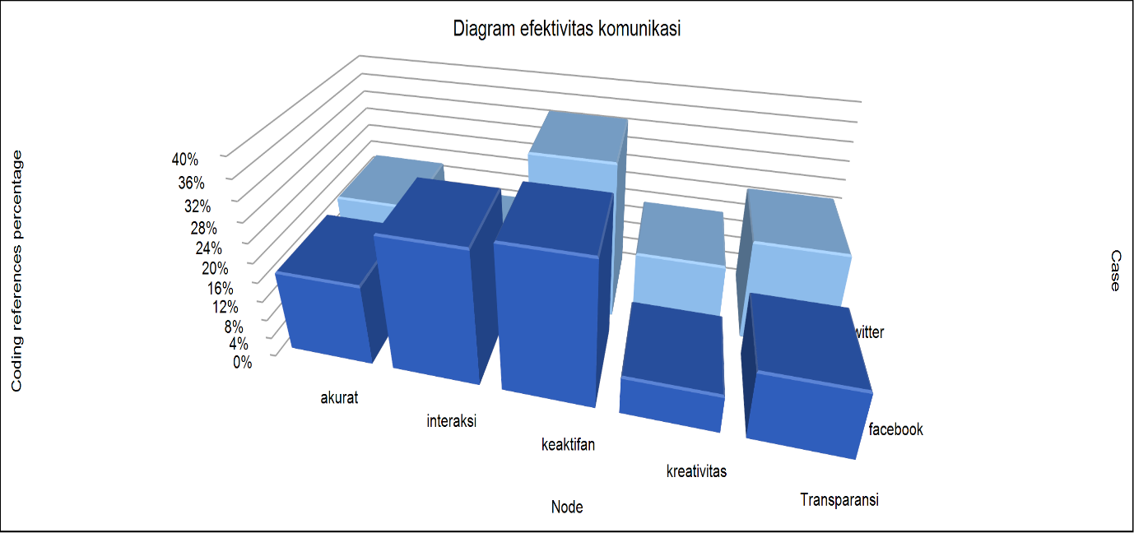
Source: Nvivo12plus
Figure 2 Communication Effectiveness of the Surabaya City Government via Twitter

Tabel 1. Efektivitas Komunikasi Pemerintah Kota Surabaya melalui Twitter
Media | Akurat | Interaksi | Keaktifan | Kreativitas | Transparansi | Total
Facebook | 17,86% | 28,57% | 30,36% | 8,93% | 14,29% | 100%
Twitter | 18,8% | 12,03% | 33,08% | 15,04% | 21,05% | 100%
Total | 18,82% | 16,93% | 32,28% | 13,23% | 19,05% | 100%
Source : Nvivo12plus

The diagram and table are the results of a comparison between the Surabaya City Government Twitter and Facebook accounts. From both, it was found that the effectiveness of communication via Twitter and communication via Facebook tends to be more effective in using Twitter. But Facebook also has advantages and influences because this social media application is used by Surabaya people of all ages and ages. Meanwhile, Twitter is usually more accessible to teenagers.
In this study, data was obtained that Twitter is more effective than Facebook. This is measured based on five aspects of the assessment, namely:

  - Accurate: in terms of accuracy, the data obtained is 18.86% for twitter. Then 18.8% for Facebook. In this case there is not much difference between the level of accuracy of communication via Twitter and Facebook, but Twitter is still superior.
  - Interaction: in terms of interaction data obtained are 12.03% for Twitter and 28.57% for Facebook. From this point of view, Facebook is higher because the communication on Facebook and its interactions can be seen directly through the comments column. Usually the public responds to government posts by providing comments.
  - Activeness: in terms of activeness, the data obtained is 33.08% for Twitter and 30.36% for Facebook. In this case, of course the Twitter account is superior. But actually posts on Twitter and Facebook have the same content because posts posted on Twitter can also be forwarded to other social media such as Facebook or Instagram. The posts on these two social media are very good because they are always updated every day.
4. Creativity: in terms of creativity, the result is 15.04% for Twitter and 8.93% for Facebook. From this assessment, Twitter is superior because the content provided on Twitter is more innovative with posts containing quizzes or challenges and challenges in creating creative content marked on the Surabaya City Government Twitter account for the community.
5. Transparency: in terms of transparency, the data obtained is 21.05% for Twitter and 14.29% for Facebook. From this point of view, communication via twitter is more transparent because seen from the posts on Twitter there is a more reciprocal relationship between the communicant and the communicator. This will certainly make it easier for people to control government activities or policies.

In addition, the communication conveyed by the government needs to be considered in using social media as a communication channel so that it has an effective influence on the audience, among others, are as follows:
- Know the audience background.
Political messages do not necessarily have a positive influence on the public. Therefore, candidates need to get accurate information about the background of society, including from the aspects of ideology, socio-culture, economic life, education level and so on.
- The process of delivering messages in accordance with the needs of the audience. The contents of the message greatly influence the audience in determining political attitudes. In packaging political messages, it should be directed to provide elegant and educating political education. Because in certain contexts, political messages which are full of political intrigue may give a negative impression to the public.
- Great political communicator.
In using social media as a communication channel, a political communicator must have the reliability and good knowledge of social media. The role of political communicators is very important as a channel of information needed by audiences.

The existence of communication through social media does have an interrelated relationship between one social media and another or between several other aspects of assessment. Therefore, the Government as a stakeholder must have a social media account that is commonly used by people of all backgrounds and ages. So that the information conveyed by the government will be channeled properly to the public. The following is a diagram that illustrates the relationship between the assessment aspects of communication effectiveness and the type of social media used via Twitter and via Facebook.

Figure 3: The results of coding similarity
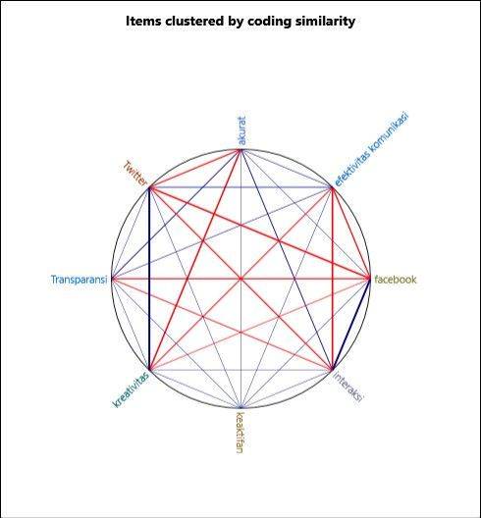
Source: nvivo12plus

The use of social media is also very much needed to support communication between the government and the community. So that there is a good reciprocal relationship between the two. However, in its application, the government is also required to be more innovative in conveying information to the public, so that people have an interest in knowing information about government and policies that have been announced. In addition, improving the quality of human resources in government institutions needs to be improved so that all forms of complaints from the public will immediately get a satisfactory response. Besides, it is also necessary to have awareness from the public to be involved in every control and evaluation of any policies that the government has implemented so that programs that are in accordance with the conditions of the community can be implemented and developed properly.

CONCLUSION
The impact of social media on the government environment is very pronounced. The Surabaya City Government in supporting policies and programs that have been implemented takes advantage of the role of social media such as Twitter and Facebook. These two media have the influence to increase the effectiveness of communication between the Surabaya City Government and the community. Because these two media are social media that have been widely used by Indonesians including the people of Surabaya. From the results of the comparison between Twitter and Facebook, it is found that Twitter has the advantage of supporting and increasing the effectiveness of communication between government agencies and the public.
To improve relations and develop effective communication, the Surabaya city government must continue to make new innovations in order to attract public interest to continue to access information related to the Surabaya city government.

REFERENCES
Adhrianti, L. (t.t.). DIGITALISASI PUBLIC RELATIONS BAGI PENGUATAN CITRA PEMERINTAH DAERAH (Analisis Deskriptif Reaktualisasi Peran Humas Pemerintah Kota Bengkulu Dalam Penyampaian Informasi Daerah Melalui Media Sosial). 11.
Anggriawan, T. P., & Mahanani, A. E. E. (2018). Harmonisasi Pengaturan Terkait Media Sosial yang Digunakan untuk Komunikasi Politik Demi Mewujudkan Pemilu Bersih dan Kondusif. Seminar Nasional Hukum Universitas Negeri Semarang, 4(03), 1141–1160. https://doi.org/10.15294/snh.v4i03.27112
Anshari, F. (2013). KOMUNIKASI POLITIK DI ERA MEDIA SOSIAL. Jurnal Komunikasi, 8(1), 91–101. https://doi.org/10.20885/komunikasi.vol8.iss1.art7
Fadilah, J. (2016). ANALISIS PERBANDINGAN EFEKTIVITAS IKLAN DI MEDIA SOSIAL FACEBOOK, TWITTER DAN INSTAGRAM. 8.
Hasan, K. (2016). NEW MEDIA DAN KOMUNIKASI POLITIK KONTEMPORER [Teaching Resource]. Diambil 22 Oktober 2019, dari http://repository.unimal.ac.id/2261/
Islamiyah, H., & Rachman, A. (2018). PERSONAL BRANDING PEJABAT PUBLIK DI MEDIA SOSIAL. ORASI: Jurnal Dakwah Dan Komunikasi, 9(1), 1–14. https://doi.org/10.24235/orasi.v9i1.2945
Munandar, H., & Suherman, M. (2016). Aktivitas Komunikasi Pemerintahan Ridwan Kamil di Media Sosial. 2, 8.
Novalinda Viani, A., & Budi Santoso, S. S. (2017). Media Baru dan Partisipasi Politik (Pengaruh Twitter Terhadap Tingkat Partisipasi Politik Remaja dalam Pilkada Serentak 2015 pada Mahasiswa Fakultas Ilmu Komunikasi dan Informatika Universitas Muhammadiyah Surakarta Angkatan 2014) (S1, Universitas Muhammadiyah Surakarta). Diambil dari http://eprints.ums.ac.id/49543/
Rasasti, T. (2017). Fungsi media sosial Facebook dan Twitter dalam mendorong proses transisi menuju masyarakat demokratis di Tunisia dan Mesir. Diambil dari repository.unpar.ac.id/handle/123456789/6417
Setiadi, A. (t.t.). PEMANFAATAN MEDIA SOSIAL UNTUK EFEKTIFITAS KOMUNIKASI. 7.
Siagian, H. F. (2015). PENGARUH DAN EFEKTIVITAS PENGGUNAAN MEDIA SOSIAL SEBAGAI SALURAN KOMUNIKASI POLITIK DALAM MEMBENTUK OPINI PUBLIK. Jurnal Al-Khitabah, 2(1). Diambil dari http://journal.uin-alauddin.ac.id/index.php/Al-Khitabah/article/view/2579
Suciska, W. (t.t.). OPTIMALISASI PENERAPAN E-GOVERNMENT MELALUI MEDIA SOSIAL DALAM MEWUJUDKAN GOOD GOVERNANCE. 16.
Susanto, E. H. (2017). MEDIA SOSIAL SEBAGAI PENDUKUNG JARINGAN KOMUNIKASI POLITIK. Jurnal ASPIKOM, 3(3), 379–398. https://doi.org/10.24329/aspikom.v3i3.123
Wahyuningtyas, D. (2017). Buzzer Twitter pada Publikasi Organisasi Pemerintah (Studi Analisis Isi Asosiasi Topik Tweet, Tujuan Tweet, Desain Penyusunan Pesan, dan Feedback Akun Buzzer Twitter Kementerian Keuangan (Other, Universitas Sebelas Maret). Diambil dari https://eprints.uns.ac.id/36425/
Widiastuti, T. W. (2017). ANALISIS ELABORATION LIKELIHOOD MODEL DALAM PEMBENTUKAN PERSONAL BRANDING DI TWITTER. Jurnal ASPIKOM, 3(3), 588–603. https://doi.org/10.24329/aspikom.v3i3.107

