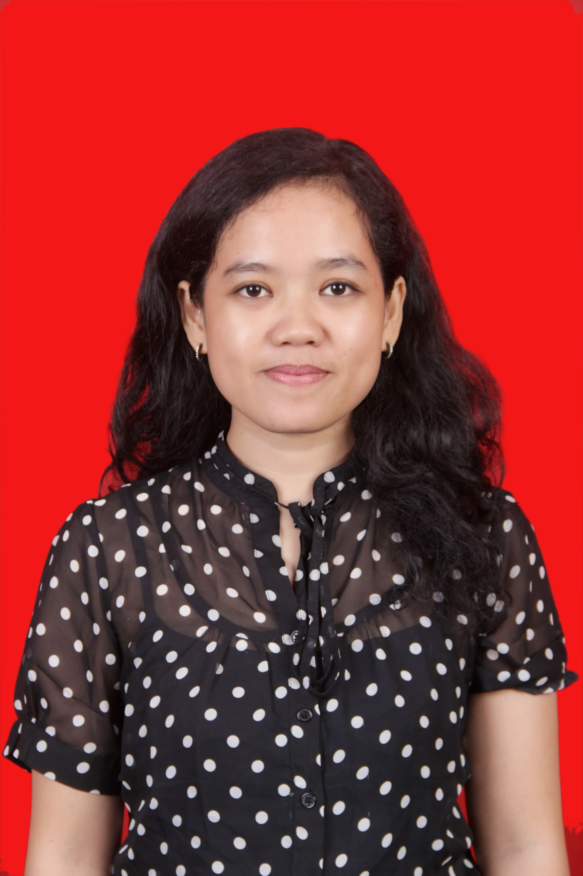
Jalan Gubeng Airlangga V, nomor 34, Surabaya
082346914129
hariansipanimba13@gmail.com

Hariansi Panimba Sampebulu’

Date of Birth : 1 October 1992

Formal Education
Aug 2017 _ Present Universitas Airlangga Surabaya, Magister Faculty of Law
Aug 2010 – Jan 2014 Universitas Pelita Harapan, Faculty Of Law
Jun 2007 – Jun 2010 Senior High School 1 Rantepao, North Toraja
Non-Formal Education

Year | Education | Institution | Explanation
2011 | Public Speaking | PR Institute Surabaya | Intermediate Level
2012 | Komisi Yudisial Discussion | Komisi Yudisial Republik Indonesia | Committee
2013 | Program Edukasi Publik | PT. Bursa Efek Indonesia | Certificate
2016 | PKPA (Pendidikan Khusus Profesi Advokat) | Warmadewa Univesity at Bali-Indonesia | Certificate
2017 | Regional Investment Forum 2017 | BPKM (Indonesia Investment Coordinating Board) | Participant

Work
Dec 2014 – August 2017 : Vidhi Law Office, Paralegal (Junior Lawyer)
Work Decription :
Handle the client in business law, criminal law, immigration, civil law and etc
Internship
Feb 2014 – Apr 2014 : Bali Safari And Marine Park Bali, Customer Service
Work Description :
Prepare the schedule, talk active with guest, playing with animal
Organizations :Head of Organizations Public Speaking Uph
Work Descprition :
Handle event in UPH and guest in tv local, practice master of ceremony, public speaking

Competency
- Hard Skill
SAP Software, Microsoft Office
English Language (Passive and Active)
- Soft Skill
Innovative, creative, teamwork, hard work

Achievement
2009 Silver Medal Champion Taekwondo Indonesia Se Indonesia Timur, Makassar
2010 - 2014 Get the Lippo Scholar for college
2016 Passed the test from Peradi and wait for inauguration to get the licensed from Peradi as a Lawyer

