Mimbar Keadilan
Jl. Semolowaru 45 Surabaya 60118, Telp. (031) 5926014
Laman: http://jurnal.untag-sby.ac.id/index.php/mimbarkeadilan
Surel: jurnalhmk@untag-sby.ac.id

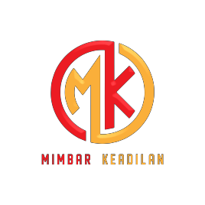
COPYRIGHT TRANSFER LETTER AND OPEN ACCESS STATEMENT

I, the undersigned below,
Full Name : Ashfi Arfawati
Institution : Sekretariat DPRD Kabupaten Sidoarjo
Address : Sultan Agung Street Number 39 ,Sidoarjo regency
Email : fifisakha@yahoo.com
Phone : 085231085085
as the Corresponding/First Researcher of the Article as a result of research with the title:

PRINSIP OTONOMI DALAM PENGELOLAAN KEUANGAN DAERAH PASCA BERLAKUNYA PERATURAN PRESIDEN NOMOR 33 TAHUN 2020 TENTANG STANDAR HARGA SATUAN REGIONAL

with researchers’ name:
Ashfi Arfawati

agreed to the following copyright transfer and open access agreement:
License of Publishing Rights
I hereby grant to the Mimbar Keadilan an exclusive publishing and distribution license in the
manuscript identified above and any tables, illustrations, or other material submitted for
publication as part of the manuscript (the “Article”) in print, electronic, and all other media (whether now known or later developed), in any form, in all languages, throughout the world, for the full term of copyright, and the right to license others to do the same, effective when the Article is accepted for publication. This license includes the right to enforce the rights granted hereunder against third parties.
Supplementary Files
With respect to Supplementary Files that I wish to make accessible through a link in the Article
or on a site or through a service of the Mimbar Keadilan, Mimbar Keadilan, shall be entitled
to publish, post, reformat, index, archive, make available, and link to such Supplementary Files on a non-exclusive basis in all forms and media (whether now known or later developed), and permit others to do so for non-commercial purposes. “Supplementary Files” shall mean additional materials that are not an intrinsic part of the Article, including but not limited to experimental data, e-components, encodings and software, and enhanced graphical, illustrative, video, and audio material.
Scholarly Communication Rights
I understand that I retain the copyright in the Article and that no rights in patents, trademarks
or other intellectual property rights are transferred to the Mimbar Keadilan,. As the researcher
of the Article, I understand that I shall have: (i) the same rights to reuse the Article as those allowed to third party users of the Article under the CC-BY-SA License, as well as (ii) the right to use the Article in a subsequent compilation of my works or to extend the Article to book length form, to include the Article in a thesis or dissertation, or otherwise to use or re-use portions or excerpts in other works, for both commercial and non-commercial purposes. Except for such uses, I understand that the license of publishing rights I have granted to the Mimbar Keadilan, gives the Journal the exclusive right to make or sub-license commercial use.

1

Mimbar Keadilan
Jl. Semolowaru 45 Surabaya 60118, Telp. (031) 5926014
Laman: http://jurnal.untag-sby.ac.id/index.php/mimbarkeadilan
Surel: jurnalhmk@untag-sby.ac.id

User Rights
The publisher will apply the Creative Commons Attribution-ShareAlike 4.0 International License (CC-BY-SA) to the Article where it publishes the Article in the Mimbar Keadilan on its online and/or offline platforms on an Open Access basis. The CC-BY-SA license allows users to copy and distribute the Article. The licenses provided the user gives appropriate credit (with a link to the formal publication through the relevant DOI), provides a link to the license, and that the licensor is not represented as endorsing the use made of the work. The full details of the license are available at https://creativecommons.org.
Reversion of Rights
Articles in the review process may be accepted or rejected for publication. Articles that have
been accepted during the review process may occasionally be rejected during the editing (in press) process. In case the article is rejected for publication (in any process), all rights associated with this agreement will revert to the researcher.
Revisions and Addenda
I understand that no revisions, additional terms, or addenda to this License Agreement can be
accepted without the Mimbar Keadilan’s express written consent. I understand that this
License Agreement supersedes any previous agreements I have entered into with the Mimbar
Keadilan in relation to the Article from the date hereof.
Copyright Notice
The publisher shall publish and distribute the Article with the copyright notice to the Mimbar
Keadilan.
Other Terms
If other researchers jointly prepare the Articles and/or Supplementary Files, I have notified other researchers of these provisions. If not reaching the consensus then I am the subject to the law in Indonesia and have chosen a common place of law in the office of the Registrar in Surabaya (Kepaniteraan Pengadilan Negeri Surabaya), in Surabaya City, Indonesia.
I make this letter with the real consciously without coercion from any party and can be used when necessary.

Corresponding/First Researcher sign : ............................................................ Date : ............................................................ Place : ............................................................
The completed form (letter) by hand writing with blue ink must be attached to PDF
supplementary file in OJS

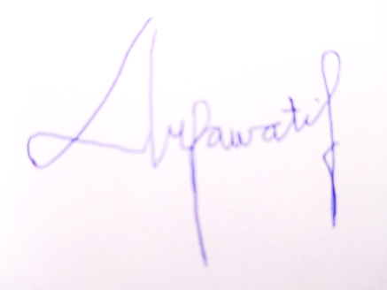

2

