Mimbar Keadilan
Jl. Semolowaru 45 Surabaya 60118, Telp. (031) 5926014
Laman: http://jurnal.untag-sby.ac.id/index.php/mimbarkeadilan
Surel: jurnalhmk@untag-sby.ac.id

STATEMENT OF MANUSCRIPT AUTHENTICITY

Full Name : Ashfi Arfawati
Institution : Sekretariat DPRD Kabupaten Sidoarjo
Address : Sultan Agung Street Number 39 ,Sidoarjo regency
Email : fifisakha@yahoo.com
Phone : 085231085085
as the Corresponding/First Researcher of the Article as a result of research with the title:

PRINSIP OTONOMI DALAM PENGELOLAAN KEUANGAN DAERAH PASCA BERLAKUNYA PERATURAN PRESIDEN NOMOR 33 TAHUN 2020 TENTANG STANDAR HARGA SATUAN REGIONAL

with researchers’ name:
Ashfi Arfawati

states the Article:
1. The Article is an original manuscript (plagiarism-free), written by the researcher listed in
the manuscript as stated in this letter with the correct order, and has not been published in any scientific publication media (national journals, international journals, national proceedings and/or international proceedings) either online or print version.
2. The manuscript is not being or will not be submitted for review or publication process in
any media before there is a decision from Mimbar Keadilan Editorial Member.
3. I am willing to follow peer-review processes based on the Mimbar Keadilan standard (including to revise the Article based on the advice from Mimbar Keadilan 's Peer-reviewer) and will not withdraw the Article that have been sent to Mimbar Keadilan before any decision by the Mimbar Keadilan Editorial Member. If the Mimbar Keadilan Editorial Member accepts my Article for publication in Mimbar Keadilan, I will not retract the Article for any reason except with the approval of the Mimbar Keadilan Editorial Member.
4. I have full access to all research data, have full responsibility for the correctness of data analysis, and have the authority to compile and submit the manuscript for publication.
5. The Article and/or Supplementary Files does not infringe copyright; not infringing
intellectual property rights (IPR); does not violate the privacy and other rights of any person, group, or legal entity; and/or does not contain anything that violates any law.
6. I have obtained written permission from the copyright owner for each excerpt of the
copyrighted work included and has been written in the references in the Article or
Supplementary Files.
7. If I use personal information or images of patients, research subjects, or other individuals,
I have obtained all necessary approvals based on the law.
8. I have written (in the manuscript) any financial or other substantive conflicts of interest that
may affect the outcome or interpretation of the research. I also have written all sources of
financial or non-financial support of research in the Acknowledgments section.

If other researchers jointly prepare the Articles and/or Supplementary Files, I have notified other researches of these provisions. If not reaching the consensus then I am the subject to the

1

Mimbar Keadilan
Jl. Semolowaru 45 Surabaya 60118, Telp. (031) 5926014
Laman: http://jurnal.untag-sby.ac.id/index.php/mimbarkeadilan
Surel: jurnalhmk@untag-sby.ac.id

law in Indonesia and have chosen a common place of law in the office of the Registrar in
Surabaya (Kepaniteraan Pengadilan Negeri Surabaya), in Surabaya City, Indonesia.
I make this letter with the real consciously without coercion from any party and can be used
when necessary.

Corresponding/First Researcher sign : ............................................................ Date : ............................................................ Place : ............................................................
The completed form (letter) by hand writing with blue ink must be attached to PDF
supplementary file in OJS

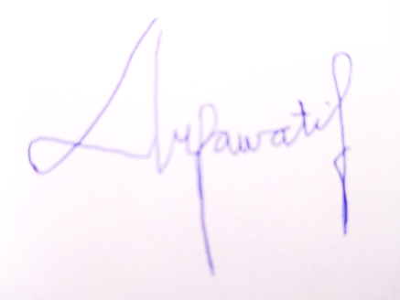

2

